|  |  |
| --- | --- |
| **Assignment No.** | 3 |
| **Name** | Nithish Bharathwaj K R |
| **Registration No.** | SSNCE195001072 |
| **Team No.** | PNT2022TMID53102 |

1. **Create a Bucket in IBM object storage.**

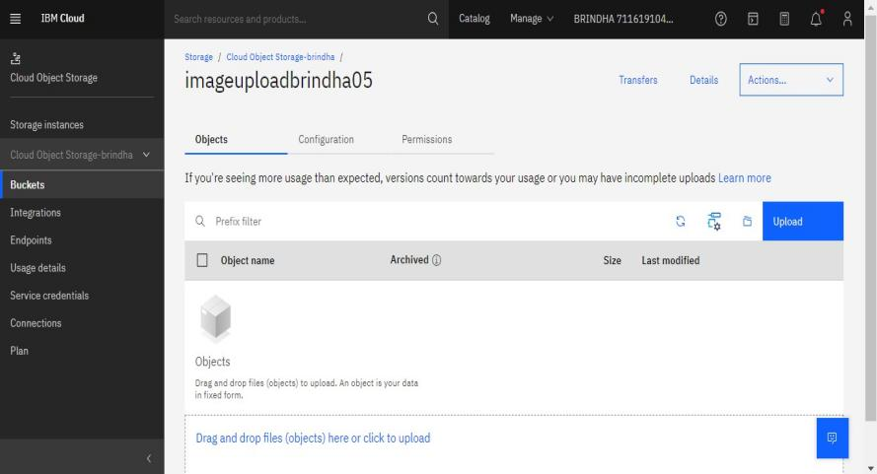

1. **Upload an 5 images to ibm object storage and make it public. write html code to displaying all the 5 images.**
   1. **adding 5 images-**

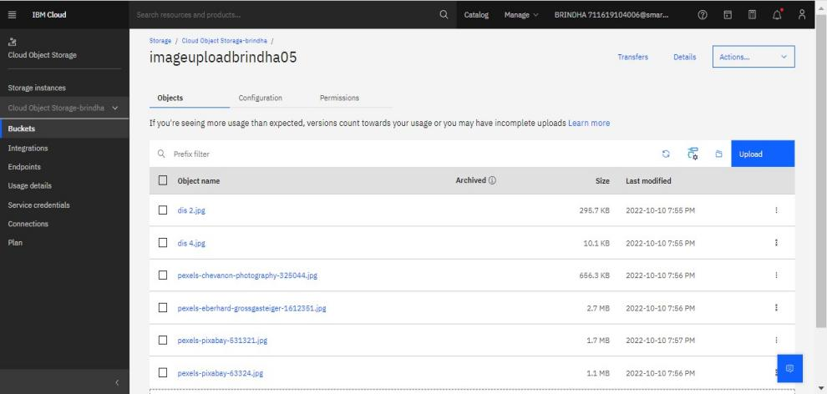

* 1. **making bucket public-**

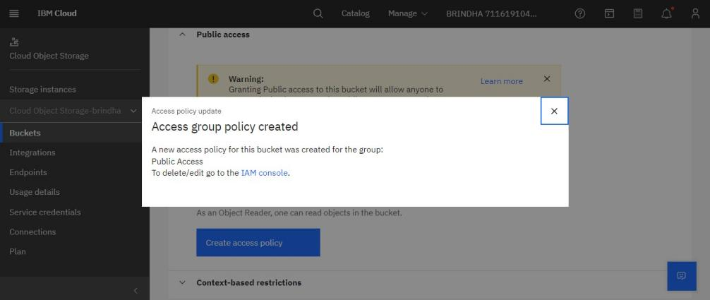

* 1. **displaying 5 images- Output-1**

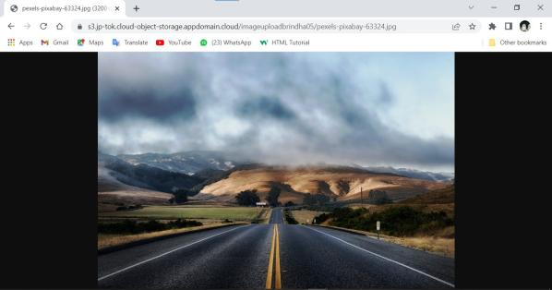

Output -2

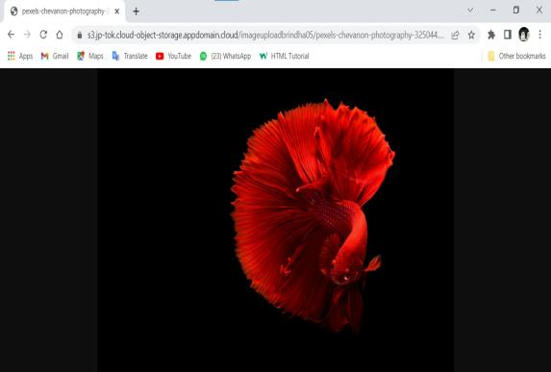

Output -3

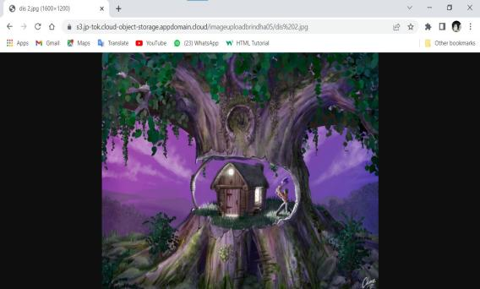

Output -4

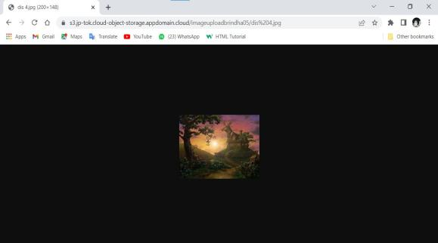

Output -5

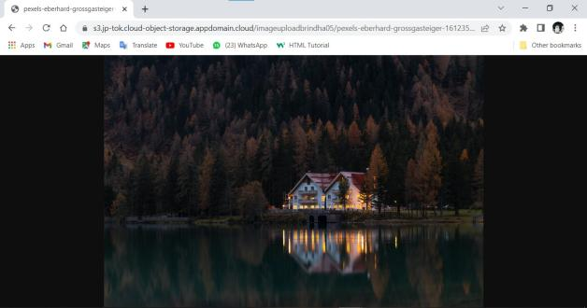

1. **Upload a css page to the object storage and use the same page in your HTML code.**
2. **Css border**

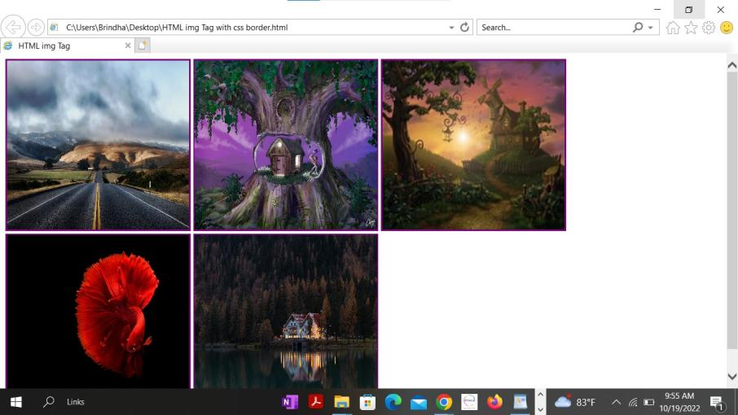

1. **css background**

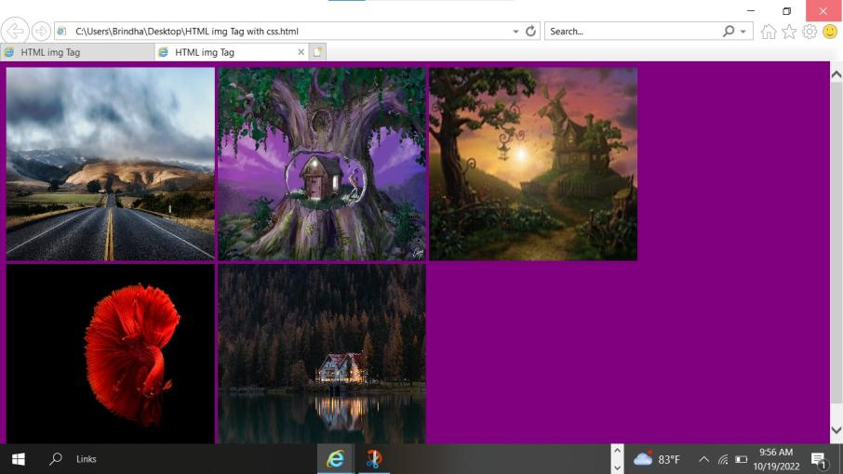

1. **Design a chatbot using IBM Watson assistant for hospital. Ex: User comes with query to know the branches for that hospital in your city. Submit the web URL of that chat bot as a assignment.**

Chatbox link:

[https: /web-chat.global.assistant.watson.appdomain.cloud/preview.html?backgro](https://web-chat.global.assistant.watson.appdomain.cloud/preview.html?backgroundImageURL=https%3A%2F%2Fau-syd.assistant.watson.cloud.ibm.com%2Fpublic%2Fimages%2Fupx-9e7dbde6-ea2a-4c36-beaf-3ef475f3f7f4%3A%3A42bd2a3a-7b71-420e-b7aa-abb774333249&integrationID=22914d72-2784-47ab-af7b-693218545daa&region=au-syd&serviceInstanceID=9e7dbde6-ea2a-4c36-beaf-3ef475f3f7f4) [undImageURL=https%3A%2F%2Fau-syd.assistant.watson.cloud.ibm.com%2Fpubli](https://web-chat.global.assistant.watson.appdomain.cloud/preview.html?backgroundImageURL=https%3A%2F%2Fau-syd.assistant.watson.cloud.ibm.com%2Fpublic%2Fimages%2Fupx-9e7dbde6-ea2a-4c36-beaf-3ef475f3f7f4%3A%3A42bd2a3a-7b71-420e-b7aa-abb774333249&integrationID=22914d72-2784-47ab-af7b-693218545daa&region=au-syd&serviceInstanceID=9e7dbde6-ea2a-4c36-beaf-3ef475f3f7f4) [c%2Fimages%2Fupx-9e7dbde6-ea2a-4c36-beaf-3ef475f3f7f4%3A%3A42bd2a3a-7b7](https://web-chat.global.assistant.watson.appdomain.cloud/preview.html?backgroundImageURL=https%3A%2F%2Fau-syd.assistant.watson.cloud.ibm.com%2Fpublic%2Fimages%2Fupx-9e7dbde6-ea2a-4c36-beaf-3ef475f3f7f4%3A%3A42bd2a3a-7b71-420e-b7aa-abb774333249&integrationID=22914d72-2784-47ab-af7b-693218545daa&region=au-syd&serviceInstanceID=9e7dbde6-ea2a-4c36-beaf-3ef475f3f7f4) [1-420e-b7aa-abb774333249&integrationID=22914d72-2784-47ab-af7b-693218545daa](https://web-chat.global.assistant.watson.appdomain.cloud/preview.html?backgroundImageURL=https%3A%2F%2Fau-syd.assistant.watson.cloud.ibm.com%2Fpublic%2Fimages%2Fupx-9e7dbde6-ea2a-4c36-beaf-3ef475f3f7f4%3A%3A42bd2a3a-7b71-420e-b7aa-abb774333249&integrationID=22914d72-2784-47ab-af7b-693218545daa&region=au-syd&serviceInstanceID=9e7dbde6-ea2a-4c36-beaf-3ef475f3f7f4) [&region=au-syd&serviceInstanceID=9e7dbde6-ea2a-4c36-beaf-3ef475f3f7f4](https://web-chat.global.assistant.watson.appdomain.cloud/preview.html?backgroundImageURL=https%3A%2F%2Fau-syd.assistant.watson.cloud.ibm.com%2Fpublic%2Fimages%2Fupx-9e7dbde6-ea2a-4c36-beaf-3ef475f3f7f4%3A%3A42bd2a3a-7b71-420e-b7aa-abb774333249&integrationID=22914d72-2784-47ab-af7b-693218545daa&region=au-syd&serviceInstanceID=9e7dbde6-ea2a-4c36-beaf-3ef475f3f7f4)

Chatbox:

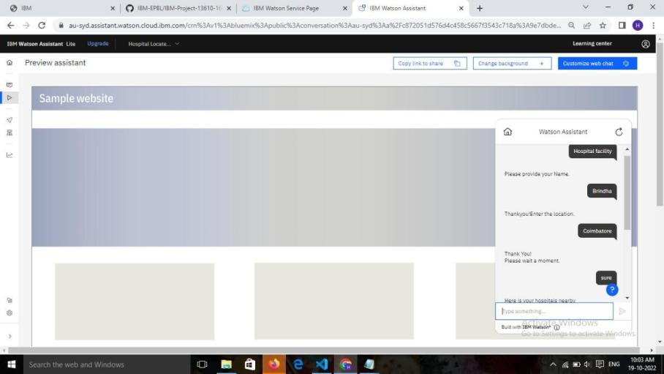

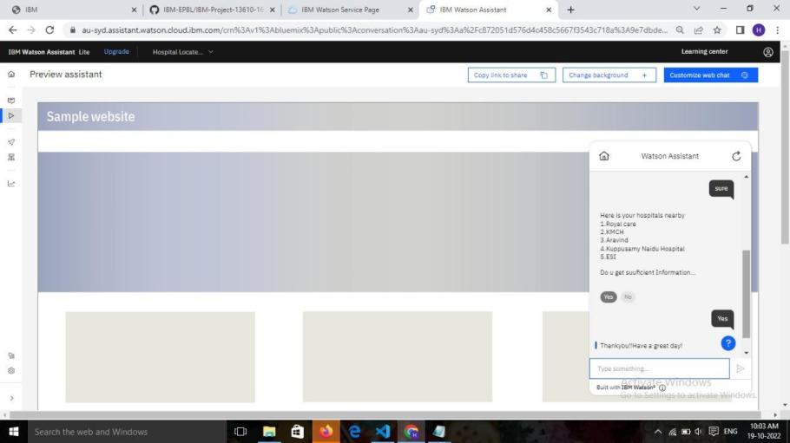

1. **Create a Watson assistant service with 10 steps and use 3 conditions in it. Load that script in the HTML page.**

